**Отчет Жалилов Актан**

1. N = 5

1, 2, 3, 4, 5

Sum = 15

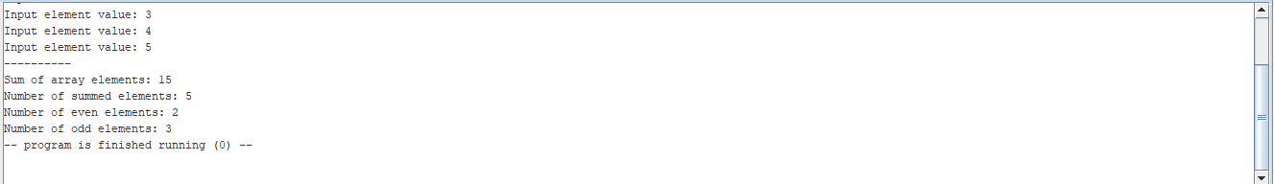

1. N = 5

-1, -2, -3, -4 , -5

Sum = -15

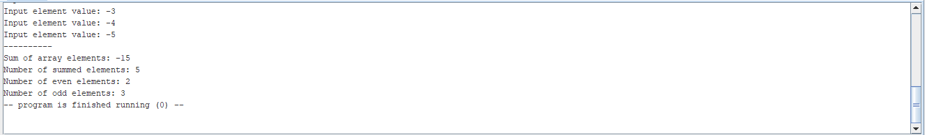

1. N = 11

Error!!!

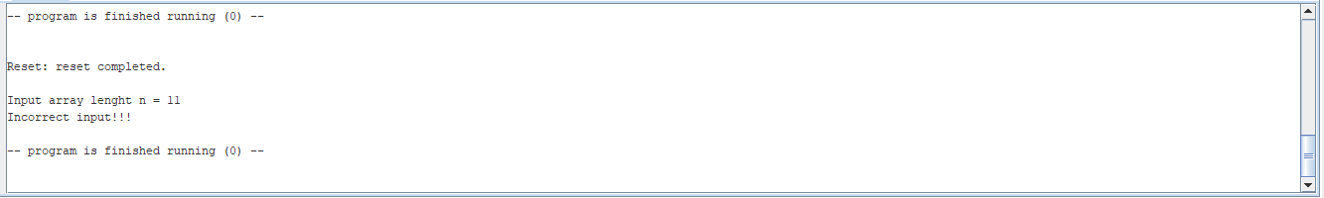

1. N = 0

Error!!!

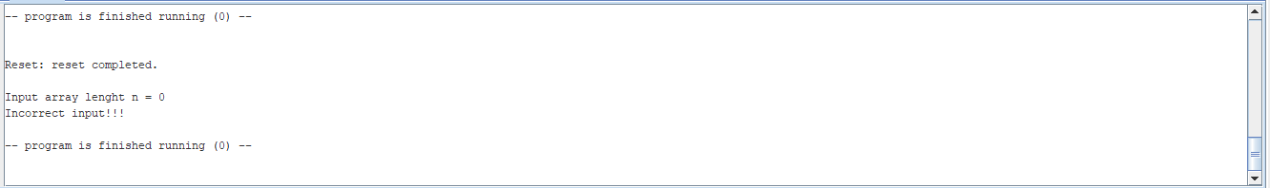

1. N = 4

1, 2, 2147483647, 4

Overflow from above!!!

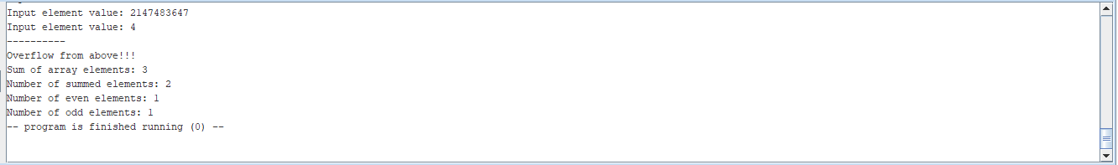

1. N = 4

-1, -2, -2147483647, -4

Overflow from below!!!

